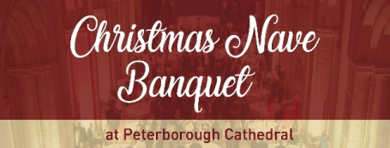

Christmas Nave Banquet, Thursday 7th December 2017
BOOKING FORM
You will find full details of this event online here: www.peterborough-cathedral.org.uk/143/section.aspx/142/nave-banquet
Booking methods
You may make your Christmas Nave Banquet booking online using a credit or debit card at http://shop.peterborough-cathedral.org.uk/nave-banquet
Alternatively, if you prefer to pay by cheque or cash, please complete and return this booking form to: Alison Jackson, Office Assistant, The Cathedral Office, Minster Precincts, Peterborough PE1 1XS.
Table and ticket prices
Please note that seating is at tables of ten to twelve. Smaller parties will be kept together as part of a table.
A table for ten guests: £900 inc. VAT (£750 + VAT)
Individual tickets: £100 inc. VAT (£83.33 + VAT)
Your booking
I’d like to book ____ table(s) at the 2017 Christmas Nave Banquet at a cost of £ _______ or
I’d like to book ____ ticket(s) for the 2017 Christmas Nave Banquet at a cost of £ ______
Name of contact: ______________________________________________________
Organisation (if applicable): ________________________________________________
Email address: ______________________________________________________
Phone number: ______________________________________________________
Once you have booked, you will receive an email from the Acting Dean of Peterborough's office confirming the arrangements. At that stage we will invite you to provide the names of your guests for the seating plan, your choices from the menu, and a note of any special dietary requirements.
Payment
I am paying by cheque / cash (please circle as appropriate).
Please make cheques payable to The Chapter of Peterborough Cathedral, with ‘Christmas Banquet’ written on the back.
Do you require a VAT receipt, sent by email to the address above? Yes / no (please circle).
Signed ______________________________________ Date _________________

